Unit 1  Making Connections in Biology |  |  | School: Koltogan General Secondary School 9
Date: |  |  | Teacher name: Zhanar Zhumabekova
Grade: 11 |  |  | Number present: |  |  | Number absent:
Theme of the lesson: |  | Modern Genetics
Learning objectives |  | 11.1.1.1 use speaking and listening skills to solve problems creatively and cooperatively in groups.  11.2.2.1 Understand most specific information in unsupported extended talk on a wide range of general and curricular topics.  11.3.7.1 Use appropriate subject-specific vocabulary and syntax to talk about an increased range of general and curricular topics.
Lesson objectives |  | Recognize the correct answers to questions using listened information and describe the pictures using appropriate topic vocabulary.
Plan
Planned  timings | Planned activities |  |  | Learners’ activities | Evaluation |  | Resources
Beginning  5 min  “Brainstorming” | 1. Greeting  2. Lead-in  Why do children look like their parents?  Why did farmers leave the best seeds for sowing?  Why are organisms similar to each other, but not an exact copy?  Why is it undesirable for close relatives to marry? |  |  | Learners greet.  Learners share their opinions. | Oral feedback
Middle  7 min  Whole class  “Vocabulary work”  activity  5 min  Group work  “Matching” activity  “Word search” activity  3 min  5 min  Pair work  “Freeze frame” activity  7 min  Individual work  “Find the answer” activity  8 min  Group work  “Fishbowl” activity | Pre-listening  New vocabulary:  inheritance explained - тұқым қуалаушылықты түсіндіру  to conduct experiments - эксперименттер жүргізу  to study heredity - тұқым қуалаушылықты зерттеу  a primary model system - бастапқы үлгі жүйесі  variation in plants - өсімдіктердің әртүрлілігі  self-pollinate - өздігінен тозаңданады  cross-pollinate - айқас тозаңданады  fundamental principles of inheritance -  different traits - әртүрлі белгілері  selective breeding - селекциялық будандастыру  homozygous - гомозиготалы  heterozygous – гетерозиготалы  a dominant allel - доминантты аллель  a recessive allel - рецессивті аллель  an individual offspring - жеке ұрпақ  dependent on genes - гендерге тәуелді болу  to pass on unchanged - өзгеріссіз өту  Concept-checking stage  Differentiation by task:  1st group  Match the words to form phrases.  a primary model different a dominant an individual dependent selective to pass on may not be to study variation allel unchanged system breeding heredity apparent traits in plants on genes offspring  2nd group  Find the words.  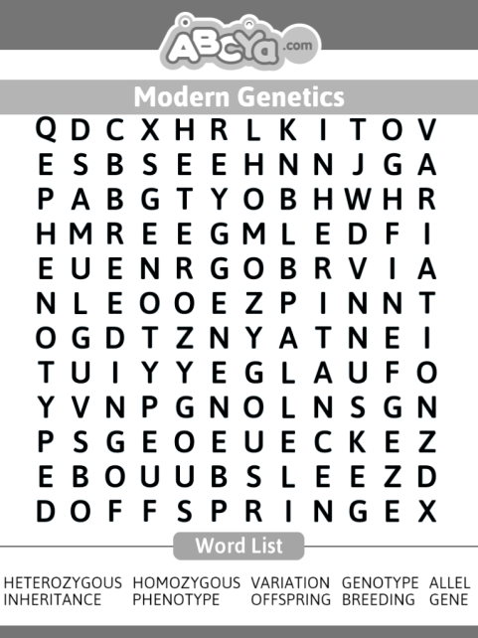  Prediction  What can you see in the picture? What do you think is the theme of today's lesson?  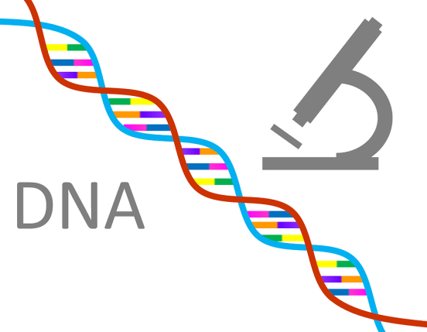  Watching the video  Watch the part of the video. Yes, you are right. Today we will speak about Modern Genetics.  Task 1 Answer the questions.  Differentiation by support:  Who was Mendel?  What did he study?  What science did he start?  Watch the video again and check your answers.  Task 2 Find the answers to the questions.  Differentiation by levels:  All learners:  What plant Mendel had chosen for his experiments?  From who are genes inherited?  Most learners:  Why Mendel had chosen pea plant for his experiments?  What does each trait depend on?  Some learners:  Why Mendel was recognized as the Father of genetics?  How are genes and their traits inherited?  Language analysis  Differentiation by content:  Look at the pictures. Describe these pictures using topic vocabulary.  1st group  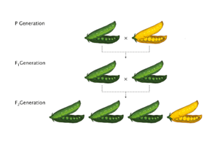  2nd group  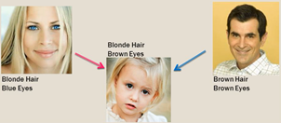 |  |  | Learners listen and repeat the new words.  Learners match the words to form phrases.  Learners find the words.  Learners guess the theme of the lesson.  Learners watch the part of the video. Then answer the gist questions  Learners watch the video to find answers for detailed questions.  Learners describe the pictures. | Oral feedback  Very good!  Good job!  Excellent!  Descriptor:  -matches the words  1 point for each correct answer  Descriptor:  -finds the words  1 point for each correct answer  Peer-assessment  “Big thumb”  Oral feedback  You are right!  You are clever!  Descriptor:  -watches the video;  -answers the questions  2 points  Self-assessment  Descriptor:  - finds answers to questions.  2 points  Formative assessment  Descriptor:  - describes the pictures  -uses topic vocabulary  3 points  Peer-assessment “Two stars and a wish” |  | PPP  Worksheets  Worksheet  https://www.youtube.com/watch?v=Fk12MdT9y6E  Cards  Pictures  https://www.shutterstock.com/ru/image-vector/mendel-genetic-concept-crossing-pea-plant-1472898935
End  5 min | Feedback  The most activities in class for me are…….  In class I don’t like……….  Today I couldn’t say because………  I have some difficulties with speaking…… |  |  |  | Self-assessment |  | A sheet of paper

